Student Name: __________________
Class and Section __________________
Total Points (20 pts) __________________
Due: April 16, 2012 before the class

Project: Dragging Points on a Circle

CSCI 1302 Advanced Programming Principles
Armstrong Atlantic State University

Draw a circle with three random points on the circle. Connect the points to form a triangle. Display the angles in the triangle. Use the mouse to drag a point along the perimeter of the circle. As you drag it, the triangle and angles are redisplayed dynamically.

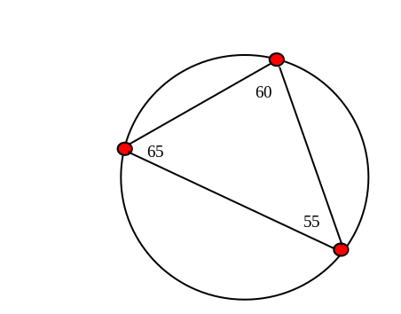

Here is the formula to compute angles:

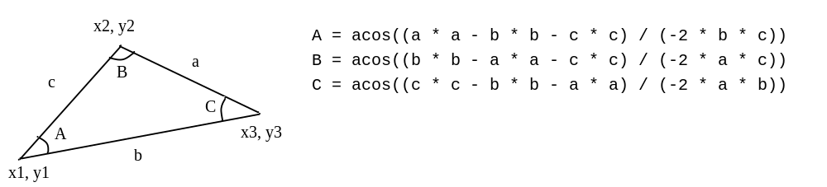

Submit to LiveLab as PExercise15_01
Bring screen shots to the class.

Submit the screen shots along with a check list of the following steps.

- Can your program display a circle in the center of the frame?
- Can your program display three points on the circle?
- Can your program draw a triangle using these three points?
- Can your program compute the angles in the triangle?
- Can your program display the angles in the triangle?
- Note that three points are three small circles. Can your program detect which small circle is pressed by the mouse?
- Can your program drag a small circle that has been pressed?
- Can your program drag a small circle along the perimeter of the circle? (Hint: Ignore the mouse drag if it is not along the perimeter of the circle.)

For the students in Jiujiang:

Here is the solution:

